**Experiment 3:** Design of Google Logo using GIMP

**Step1:** Open GIMP, go to File→New file→ & choose 1080x1080 size screen keeping the background white.

**Step2:** Go to Image→ Guides→Guides by %→ and choose the 50% horizontal guide and 50% vertical guide subsequently.

**Step3:** Now choose the Ellipse tool from toolbar, and start drawing a circle at the quadrant of your choice. Use Ctrl+Shift to position it at the center.

7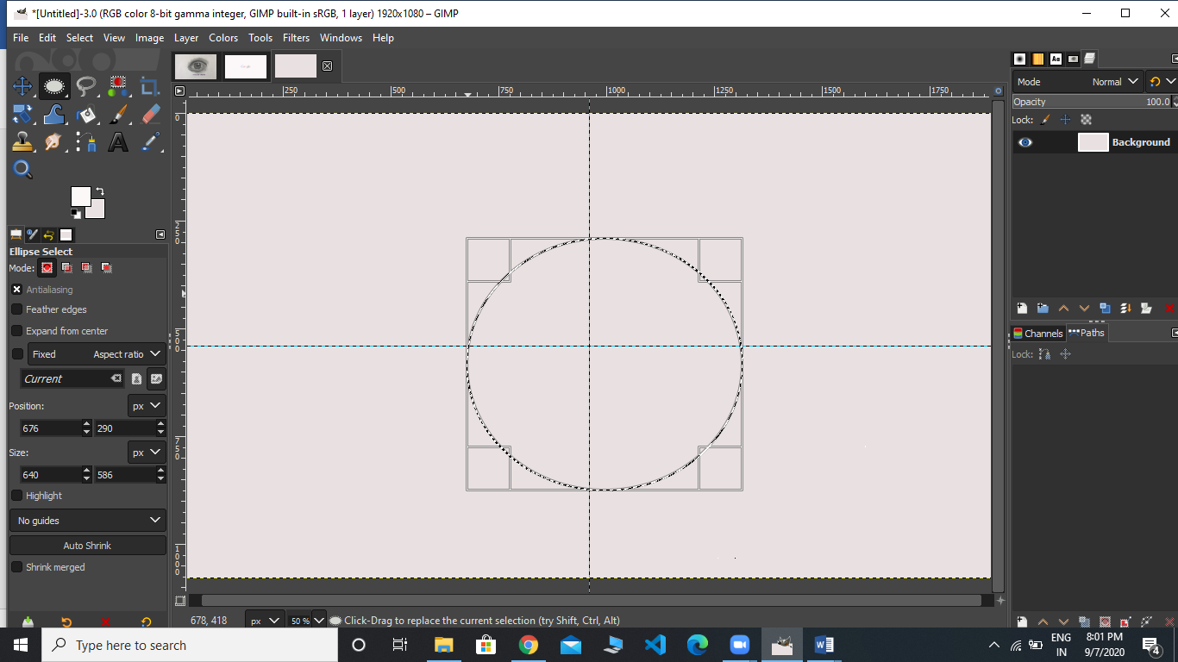

**Step5:** Go to path→Make the selection visible→ Now, add it to the text.

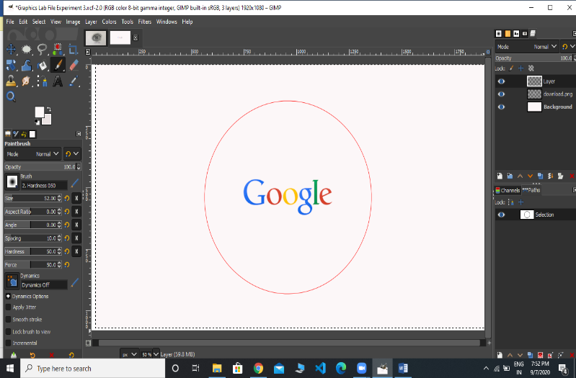

**Step6:** Right-click on the text layer, choose text along path→ go to path and add a new layer to it.

**Step7:** Go to Path, Text1→ Transparent, Fill the path→solid color→ delete text1 path.

**Step8:** Now for Text2, click on Toolbar→ Flip tool→ Transform row→ Direction Flipping.

**Step9:** Now go to the Text layer→ right-click on Text-2→ Text along path→ Adjust the position of 2nd text by rotate tool under the toolbar box.

**Step10:** Add new layer from Text2, select that Layer→Go to the path→ Right click on it, select text along path. Select Fill with solid color option.

**Step11:** Go to File and open the Google logo as layer and place it in the center and make other layers invisible using the eye sign on the right of the layers/selections.

**Step12:** Save the output and export it at another location using .XCF extension.